PUNJAB SCHOOL OF LAW
PUNJABI UNIVERSITY, PATIALA
(Established under Punjab Act No. 35 of 1961)
B.A.LL.B Five Year Course
(Semesters 3rd and 4th)
for 2015-16, 2016-17 and 2017-18 sessions.
Scheme of Studies
Third Semester
Paper Subject Univ. Int. Max
Exam Assess. Marks
- Economics-I 74 26 100
- History-I 74 26 100
- Punjabi-I or Punjabi(Basic Knowledge) -I 74 26 100
- Constitutional Law-I 74 26 100
- Family Law-I 74 26 100

Total 370 130 500

Fourth Semester
Paper Subject Univ. Int. Max
Exam Assess. Marks
- Economics-II 74 26 100
- History-II 74 26 100
- Punjabi-II or Punjabi(Basic Knowledge) –II 74 26 100
- Constitutional Law-II 74 26 100
- Family Law-II 74 26 100

Total 370 130 500

GENERAL INSTRUCTIONS FOR THE PAPER
SETTER FOR ALL THE PAPERS
- The maximum marks for each paper are 74 and the time allowed is 3 hours.
- The minimum number of marks required to pass each paper shall be 45% in University Examination and 45% in University Examination and Internal Assessment taken together.
- The question paper will consist of three units : I, II and III. Unit I and II will have four questions from respective units of the syllabus and will carry 11 marks each. Unit III will consist of 10 short- answer type question, which will cover the entire syllabus uniformly and will carry 30 marks in all.Internal exams marks for each paper are 26 which includes 05 marks of Attendance, 11 marks of Written Assignment/Project Work etc. and 10 marks for Two Mid- Semester Tests/Internal Examination.

B.A.LL.B- (3rd Semester)

Paper-I:- Economics-I
Unit – I

Economics : Definitions, Nature and Scope, Relevance of Law
Types of Economy: Socialistic, Capitalistic and Mixed Economy
General Principles of Economics: Demand, Supply, Utility, Consumer’s Surplus

Unit – II

Determination of Price and output under perfect competition, Monopoly and Monopolistic Competition
Theories of Wages, Rent, Interest and Profits
Say’s Law of Markets, Keynes theory of Income, Employment and Output, Multiplier

Suggested Readings

- P.N Chopra, Principles of Economics
- K.P.M Sundaram, Elementary Economics
- Dewett & Verma, Elementary Economic Theory
- K.C. Rana and K.N. Verma, Macro Economics
- H.L. Ahuja, Advanced Economic Theory

B.A.LL.B- (3rd Semester)
Paper-II:- History of India – I
Unit – I
Society and legal system in Ancient India.
Family and condition of Women in Vedic Period.
Varna System and Caste System.
Local And Village Administration during Rig Vedic and later Vedic Period.
Mauryas and Guptas Administration: Civil, Judicial, Revenue and Military Administration.
Sultante and Mughal Administration: Civil, Judicial, Revenue and Military Administration.

Unit – II
Constitutional development in India during British Rule with special reference to Justice, Judicial and Legal System 1773 to 1857 ( Regulating Act of 1773, Charter Act,1774, Act of Settlement--- 1781, PiTi’s India Act of 1784, Company’s Charter Act 1813, Charter Act 1833, Charter Act 1853, Govt. of India Act, 1858.
Major Judicial Systems of World : U.K., U.S.A., France
Suggested Readings
1. R.C. Majumdar : Ancient India.
2. B.S Sharma : Ancient India.
3. A.L Basham : The Wonder that was India.
4. A.L. Srivastava : Delhi Sultante.
5. A.L. Srivastave : Mughal Sultante.
6. R.C. Majumdar, H.C. Roychoudhary : An Advanced History of India.
7. Shekhar Bandhyupadhyay : From Plassey to Partition – A History of Modern India.
8. Bipin Chandra : Modern India.
9. Tara Chand : History of the Freedom Movement in India.
10. J.K. Mittal : Legal and Constitutional History of India.
11. National Book Trust : Freedom Struggle.
12. J.S Badayal : Comparative Study of Major Political System.

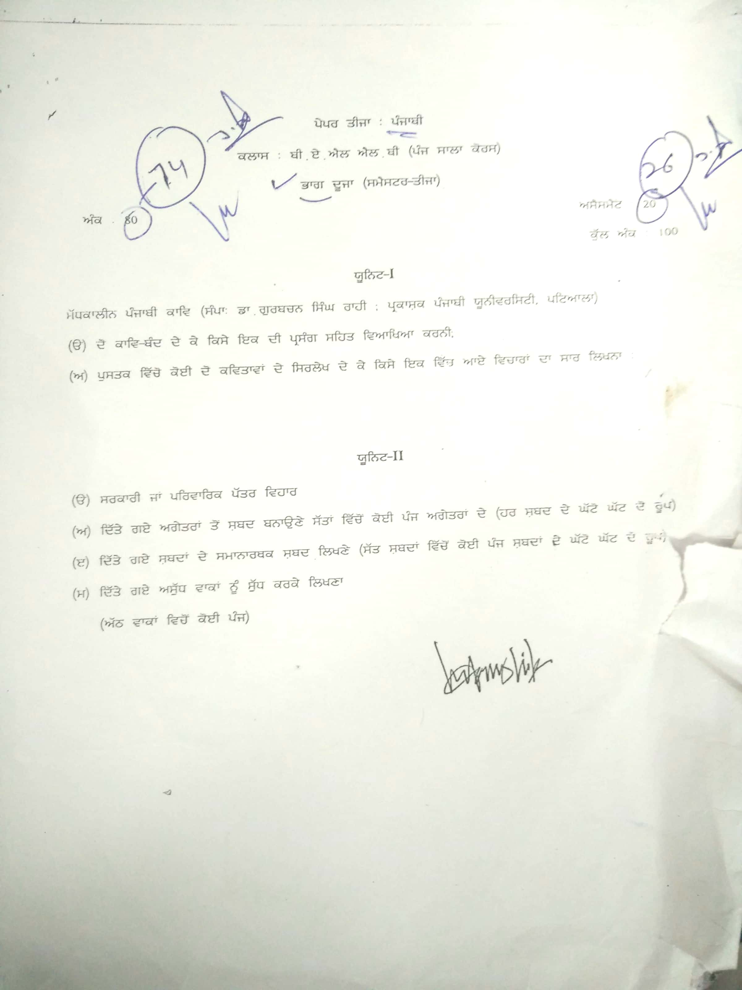

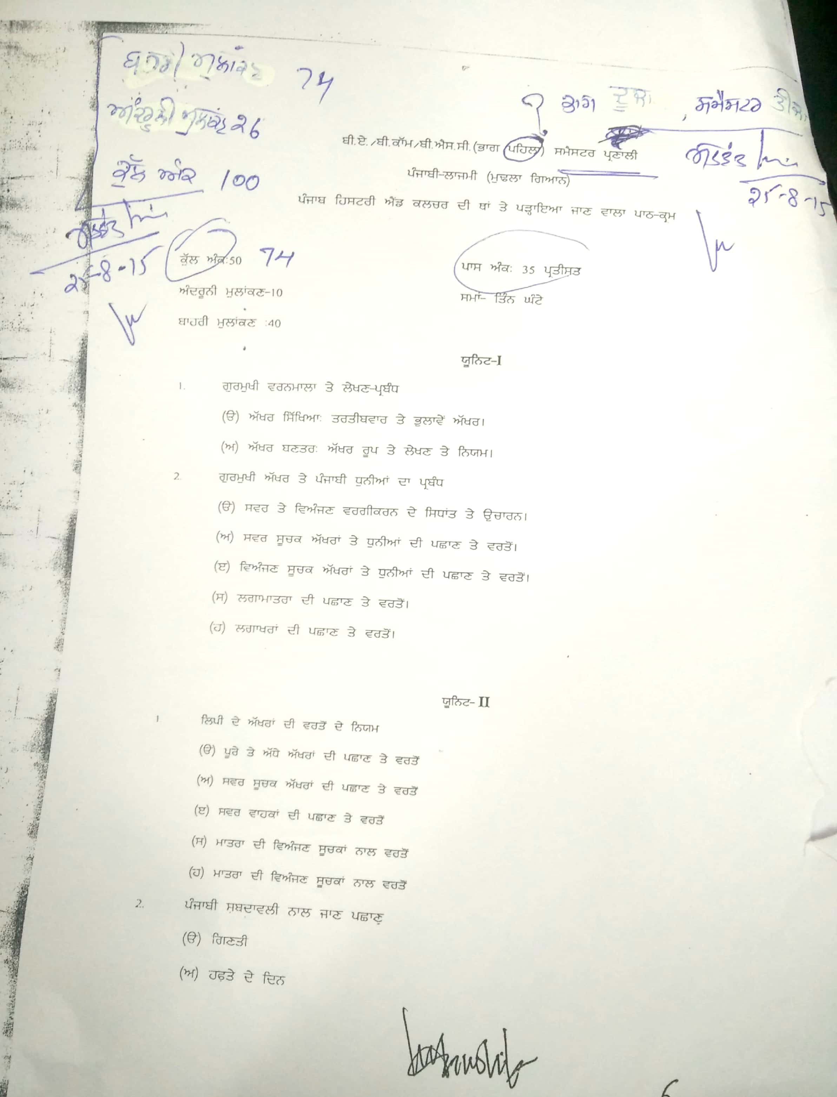

B.A.LL.B- (3rd Semester)
Paper- IV: CONSTITUTIONAL LAW-I
UNIT –I
Nature and Salient Features of the Indian Constitution
The Preamble of the Constitution
Fundamental Rights
Directive Principles of State Policy
Fundamental Duties

UNIT -II

The Union and its Territory
Citizenship
The Union Judiciary
The State Judiciary
Writs

SUGGESTED READINGS

1. M.P.Jain : Constitutional Law.
2. D.D. Basu : Introduction to Constitution.
3. S.N.Shukla : Constitution of India.
4. H.M Seervai : Constitutional Law of India.
5. J.N.Pandey : Constitutional Law of India.

B.A.LL.B- (3rd Semester)
Paper-V: Family Law-I
Unit – I
Sources of Hindu Law
- Ancient Sources
- Modern Sources
The Hindu Marriage Act, 1995
- Application of Hindu Law
- Conditions of Marriage
- Ceremonies of Marriage
- Registration of Marriage
Matrimonial remedies under the Hindu Marriage Act, 1955
Restitution of conjugal rights
Judicial Separation
Nullity of Marriage
- Void marriage
- Voidable marriage
Divorce
Divorce by mutual consent
Customary Divorce
Legitimacy of children
Jurisdiction
Bars of matrimonial remedies
Maintenance Pendente Lite
Permanent alimony and Maintenance
Unit – II
The Special Marriage Act, 1954
Conditions of Marriage
Registration of Marriage
Restitution of Conjugal rights
Judicial Separation
Nullity of Marriage
- Void Marriage
- Voidable Marriage
Divorce
Divorce by mutual consent
Muslim Law
- Marriage
- Dower
- Divorce
The dissolution of Muslim Marriage Act, 1939

Suggested Readings
- Dr. Paras Diwan : Modern Hindu Law.
- Mulla : Principles of Hindu Law.
- G.M. Divekar : Hindu Law
- Ramesh Chander Nagpal : Modern Hindu law
- Mayne : Hindu Law
- Raghvachariar : Hindu Law
- Kusum : Family Law Lectures-I
- Poonam Pradhan Saxena : Family Law Lectures-II
- Srinivasan : Special Marriage Act
- Dr. Paras Diwan : Muslim Law in Modern Ind.
- Aqil Ahmed : Mohammadan law
- vk a dbihs f;zx L fjzd{ ftnkj ns/ sbke dk ekB{zB (gzikph)
- Dr. Basant Kumar Sharma : Hindu Law

B.A.LL.B- (4th Semester)
Paper-I:- Economics-II
Unit-I
Economic Growth and Economic Development, Determinants of Economic Development
Problems of Economic Development : Population, Poverty, Unemployment and Regional and Income Inequalities
Strategies of Economic Development : Balanced and Unbalanced growth, Leibensteins’ Critical Minimum Effort theory, Theory of Big Push
Unit – II
Planning : Definitions, Need, Objectives, Types, Strategy, and adoption in India
Role of Public and Private Sector, Problem of Public sector Units, Deficit Financing
International Financial Institutions : IBRD, IMF, ADB, Liberalisation and EXIM Policy

Suggested Readings

- Rudar Dutt and Sundhram, Indian Economy, Delhi, S. Chand & Co. Publications.
- A.N: Aggarwal, Indian Economics, New Delhi Vikas Publications, 1979.
- B.K Dhar, Indian Economy.
- Tadaro M.P., Economic Development.
- S.K. Mishra and V.K. Puri, Indian Economy.
- K.C. Rana and K.N. Verma, Macro Analysis.
- M.L. Taneja and R.M. Myer, Economics of Development and Planning.
- M.L Jhingan, The Economics of Development and Planning.

B.A.LL.B- (4th Semester)
Paper-II:- History of India – II
Unit – I
Cause and Nature of The Revolt of 1857
Social Reform Movements: Causes for the origin of Socio- Religious reform movements of 19th Century, Brahmo samaj, Arya Samaj, Aligarh Movement, Namdhari Movement, Singh Sabha Movement.
Rise of Nationalism : Causes of the rise of National Consciousness , Rise of Moderates and Extremists Freedom Struggle under Gandhi : Episode of Jallianwala Bagh, Non Cooperation Movement, Civil Disobedience Movement, Quit India Movement, Cripps Mission, Cabinet Mission, Wavell Plan.
Problem of Communalism
Circumstances leading to the Partition of India.
Unit - II
Political/Judicial and Constitutional Developments : The Indian Council Act of 1892, Govt. of India Act 1909, Govt. of India 1919, Govt. of India 1935 and Independence Act, 1947.
Institutional Development under British Rule ---Bureaucracy and Judiciary.
History of Legal Education and Legal Profession.
Various Reforms Introduced by Warren Hastings, Lord Cornwallis and William Bentick.
Suggested Readings
- K.W. Jonne : Socio Religious Reform Movements.
- Sumit Sarkar : Social History of Modern India.
- G.K. Puri, S. Sharma, M.B. Julka : Indian History (IIMS)
- D.N Kundra : A New History of Modern India.
- V.D. Kulshreshta : Legal and Constitution History of India.
- J.S Badayal : Comparative Study of Major Political System.
- Sumit Sarkar: Modern India
- Ishita Banerjee – Dube : A History of Modern India ( Cambridge University )
- Shekhar Bandhyupadhyay : From Plassey to Partition – A History of Modern India.
- Bipin Chandra : History of Modern India.
- L.P Sharma, Lakhsmi Narayan : Indian National Movement.
- K.L. Khurrana : Modern India.
- R.C. Majumdar, H.C Roychoudhary : An Advanced History of India.

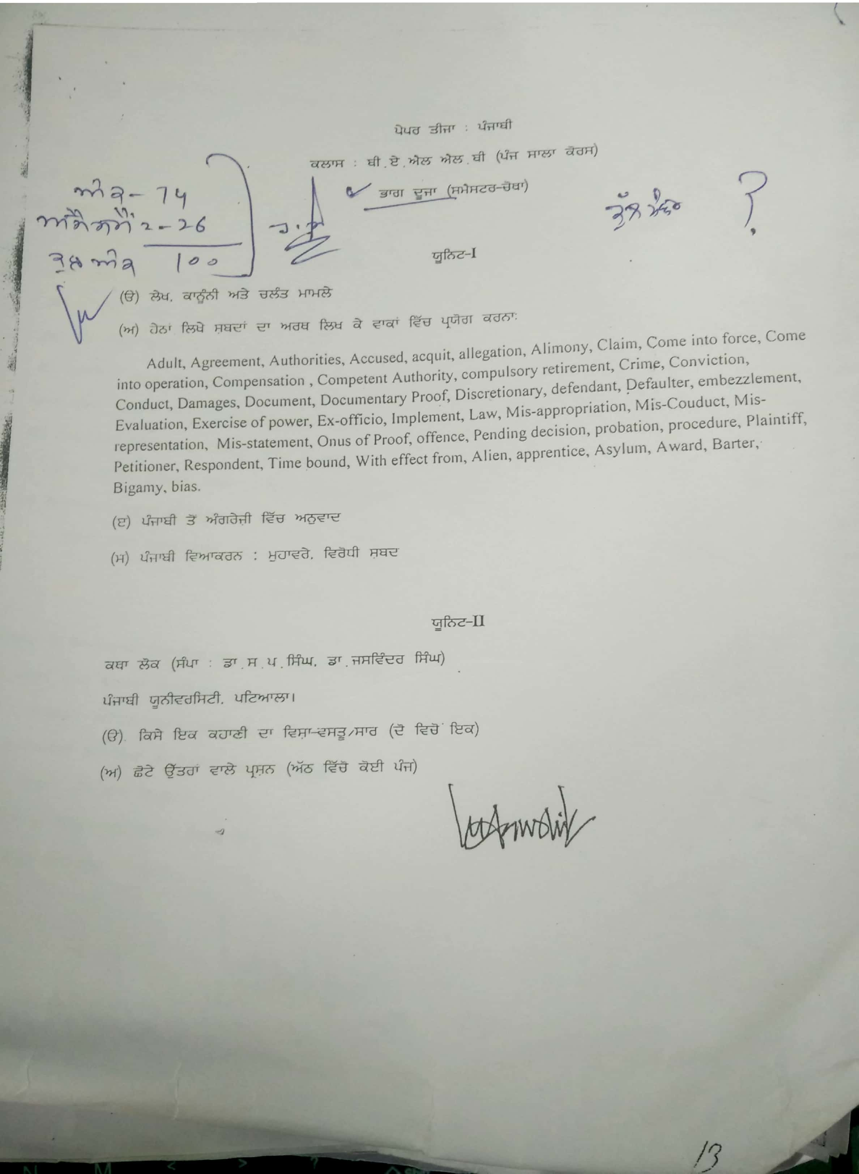

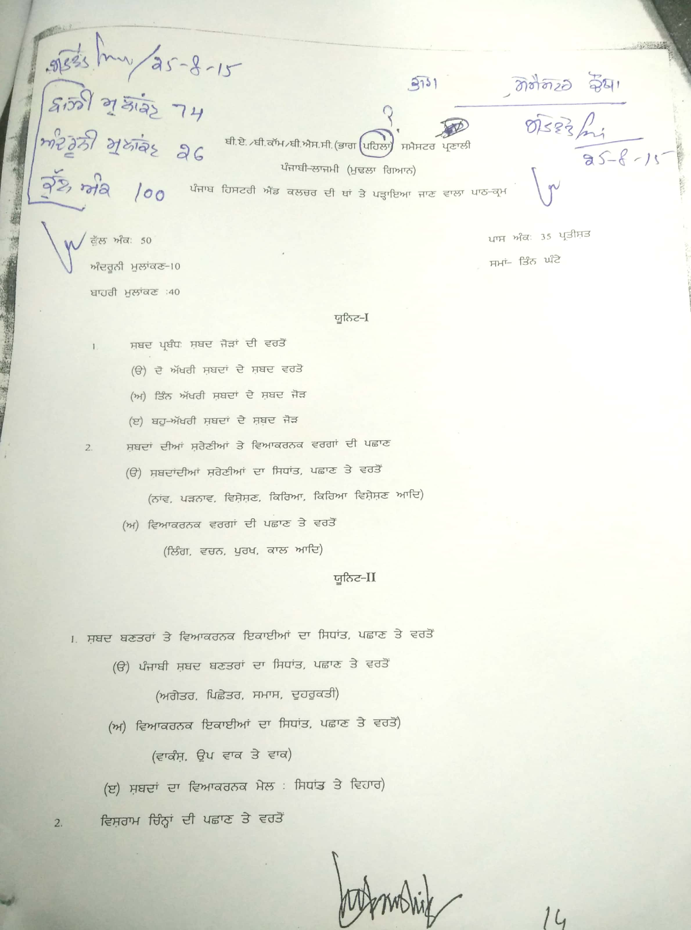

B.A.LL.B- (4th Semester)
Paper- IV: CONSTITUTIONAL LAW-II
UNIT -I
The Parliament.
The State Legislature.
Privileges of Legislature.

Legislative relations between Union and State.
Administrative relations between Union and States.
The State Liability.
UNIT -II
Emergency Provisions.
Election Commission.
Freedom of Trade, Commerce and Intercourse.
Civil Servants.
Service Tribunals.
Amendment of the Constitution & Doctrine of basic Structure.

SUGGESTED READINGS

1. M.P.Jain : Indian Constitutional Law.
2. D.D. Basu : Introduction to Constitution.
3. S.N.Shukla : Constitution of India.
4. H.M Seervai : Constitutional Law of India
5. The Constituent Assembly Debates.

B.A.LL.B- (4th Semester)
Paper- V:- Family Law-II
Unit-I
Adoption under the Hindu Adoption and Maintenance Act, 1956
Who may take in adoption
Who may give in adoption
Who may be given in adoption
Other conditions and ceremonies of adoption
Effects of adoption
Relationship of adopted child
Maintenance under the Hindu Adoption and Maintenance Act, 1956
Maintenance of wife
Maintenance of widow daughter-in-law
Maintenance of children and aged parents
Maintenance of dependents
Amount of Maintenance
Guardianship under the Hindu Minority and Guardianship Act, 1956
Kinds of Guardian
Natural Guardian
Powers of Natural Guardian
Testamentary Guardian
Guardianship of Minor’s property
Custody of Minor
Consideration for appointment of guardian
The Family Courts Act, 1984
Unit-II
Schools of Hindu Law
Joint Family and Coparcenary
Classification of property
Joint Family Property
Separate or self-acquired property
Karta of the Hindu Joint Family, its position and powers
Partition
The Hindu Succession Act, 1956
Devolution of interest in Mitakshara Coparcenary
Succession of Property of Hindu Male dying intestate
Succession of Property of a Hindu female dying intestate
General provisions relating to succession
Disqualification relating to succession

Suggested Readings

- Dr. Paras Diwan : Modern Hindu Law.
- Mulla : Principles of Hindu Law.
- G.M. Divekar : Hindu Law
- Ramesh Chander Nagpal : Modern Hindu law
- Mayne : Hindu Law
- Raghvachariar : Hindu Law
- Kusum : Family Law Lectures-I
- Poonam Pradhan Saxena : Family Law Lectures-II
- Dr. Paras Diwan : Law of adoption Minority
- Dr. Paras Diwan : Guardianship and Custody

SYLLABUS
BACHELOR OF LAWS. PART-III
(5 YEAR COURSE) (FIFTH AND SIXTH SEMESTERS)
FOR 2015-16 SESSIONS
SCHEME OF STUDIES

FIFTH SEMESTER

Paper | Subject | University Exam. | Internal** Assessment | Max. Marks
1 | Legal History | 80 | 20 | 100
2 | Environment Law | 80 | 20 | 100
3 | Law of Property | 80 | 20 | 100
4 | Labour and Industrial Law-I | 80 | 20 | 100
5 | Administrative Law | 80 | 20 | 100
 | Total | 400 | 100 | 500

SIXTH SEMESTER

Paper | Subject | University Exam. | Internal** Assessment | Max. Marks
1 | Jurisprudence | 80 | 20 | 100
2 | Principles of Taxation | 80 | 20 | 100
3 | Company Law | 80 | 20 | 100
4 | Labour and Industrial Law-II | 80 | 20 | 100
5 | Option: Any one of the following:  (a) International Organisations  (b) Gender Justice | 80 | 20 | 100

