Advance Diploma in Career Counselling
Session 2022-23, 2023-24, 2024-25 Examinations
Semester I
Advance Diploma in Career Counselling (Theory Paper) 6 periods per week
Max. Marks : 40

INSTRUCTIONS FOR THE PAPER-SETTER
The question paper will consist of three sections A, B and C. Syllabus of each section (i.e. A&B) will have two subparts. Examiner will set two questions from Section A (each question having internal choice covering both parts of syllabus of section A) and two questions from section B ( each question having internal choice covering the entire syllabus of section B). Each question will carry 7 marks. Section C is compulsory, and shall comprise six short answer type questions carrying 2 marks each. The short type answer should be written in approximately 50 words i.e. 5-7 lines.

INSTRUCTIONS FOR THE CANDIDATES
Candidates are required to attempt one question from each subpart of both the sections A & B of the question paper and the entire section C. The short type answer should be written in approximately 50 words i.e. 5-7 lines.
SECTION -A
(i) Introduction to Career Counselling: Objectives and scope. Characteristics of an effective counsellor.
(ii) Career Counselling Stages: Rapport Building, Intake Procedures, Goal-Setting, Interpretation

SECTION -B
(i) Eementary, Middle and Secondary School Counselling
(ii) Services for school Children: Under Achievers, Gifted, Mentally Retarded, learning Dsabled

REFERENCES
- Gladding, S.T. (1996). Counselling-A Comprehensive Profession. NJ: Prentice-Hall.
- Gibson, R.L. (1998). Introduction to Counselling and Guidance. NJ: Prentice Hall.
3. Kochar, S.K. (1989) Educational and Vocational Guidance in Secondary Schools. New Delhi: Sterling
4. Rao, N.S. (1993). Counselling and Guidance. Delhi : Tata McGraw Hill Publishing Co.
5. Arulmani, G& Nag- Arulmani,S(2004), Career Counsellin g: A Handbook, New Delhi: Tata McGraw Hill
Advance Diploma in Career Counselling (Practical Paper) Max Marks : 10
Practical Paper: Intellligence Testing
Personality Testing

Advance Diploma in Career Counselling
Session 2022-23, 2023-24, 2024-25 Examinations
Semester II
Advance Diploma in Career Counselling (Theory Paper) 6 periods per week
Max. Marks : 40

INSTRUCTIONS FOR THE PAPER-SETTER
The question paper will consist of three sections A, B and C. Syllabus of each section (i.e. A&B) will have two subparts. Examiner will set two questions from Section A (each question having internal choice covering both parts of syllabus of section A) and two questions from section B ( each question having internal choice covering the entire syllabus of section B). Each question will carry 7 marks. Section C is compulsory, and shall comprise six short answer type questions carrying 2 marks each. The short type answer should be written in approximately 50 words i.e. 5-7 lines.

INSTRUCTIONS FOR THE CANDIDATES
Candidates are required to attempt one question from each subpart of both the sections A & B of the question paper and the entire section C. The short type answer should be written in approximately 50 words i.e. 5-7 lines.
SECTION -A
Ethical and Legal Issues in Career Counselling
(i) Confidentiality& Privacy, and Client Welfare
(ii) Informed Consent and Debriefing
SECTION -B
(i) Career Counselling : Job Analysis, Job Performance, Job placement, Job Satisfaction
(i) Group Counselling : Scope, Techniques, Advantages & Limitations

REFERENCES
- Gladding, S.T. (1996). Counselling-A Comprehensive Profession. NJ: Prentice-Hall.
- Gibson, R.L. (1998). Introduction to Counselling and Guidance. NJ: Prentice Hall.
3. Kochar, S.K. (1989) Educational and Vocational Guidance in Secondary Schools. New Delhi: Sterling
4. Rao, N.S. (1993). Counselling and Guidance. Delhi : Tata McGraw Hill Publishing Co.
5. Arulmani, G& Nag- Arulmani,S(2004), Career Counsellin g: A Handbook, New Delhi: Tata McGraw Hill

Advance Diploma in Career Counselling (Practical Paper) Max Marks : 10
Aptitude Test, Interest Testing

PUNJABI UNIVERSITY, PATIALA

SYLLABUS
FOR
POST GRADUATE DIPLOMA IN COUNSELLING FOR SUBSTANCE
ABUSE PREVENTION AND TREATMENT
ANNUAL
For 2023,2024, 2025 Examination

(For Distance Education)

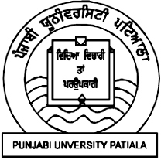

PUNJABI UNIVERSITY, PATIALA
(All Copyrights reserved with the University)

ORDINANCES
POST GRADUATE DIPLOMA IN COUNSELLING FOR SUBSTANCE ABUSE PREVENTION AND TREATMENT
(ANNUAL)
(For Distance Education)
- The course shall be a one year Post Graduate Diploma in Counselling for Substance Abuse Prevention and Treatment and the certificate shall be called “Post Graduate Diploma in Counselling for Substance Abuse Prevention and Treatment”.
- Subject to the control and general supervision of the Academic Council, the instruction and routine in Post Graduate Diploma Course in Counselling for Substance Abuse : Prevention and Treatment shall be under the direction of the Dean of the faculty of social sciences and the department of Distance education in collaboration with Psychology department for teaching purposes.
- The duration of the course shall be of one year commencing from July each year.
- Every candidate seeking admission to the Post Graduate Diploma in Counselling for Substance Abuse Prevention and Treatment must be a graduate in any stream from a statutory university and possess such further qualifications as may be prescribed by the ordinances from time to time.
- The examination fee and schedule for payment of fees shall be such as prescribed from time to time as per university rules.
- The course shall have 4 papers including 3 theory and 1 project report. Each theory paper will be of 100 marks as well as project will be of 100 marks( 50 for Project Report and 50 for viva). Total marks will be 400.
- The Project Report may be submitted without any late fee on or before 31st May of every session. Candidates failing to submit the project report within stipulated time will be charged with late fee of Rs 500/ per month after 31 May till August that too with the permission of Dean, Academic Affairs on recommendation of subject in-charge and head of the department of distance education upto three months.
Beyond three months, as special case, with the permission of Vice Chancellor and with the fee of Rs 5000/- in addition to Rs. 500 per month till November . No further extension will be allowed beyond month of November.
- Fee charged for project report submission will be utilized for the evaluation of project report, conducting viva and other related expenses.
- Rs. 100 /- per project will be paid as evaluation fee to the evaluator of project reports and Rs 50/- will be paid to internal examiner.
- Viva –Voce of candidate submitting project report after the stipulated time i.e 31 may will be conducted in next session.
- Personal Contact Programme (PCP) is compulsory. Two P.C.P of 7-9 days duration shall take place. It will be compulsory for every student to attend at least 75% lectures from any one Personal contact Programme. Those falling short of 75% attendance shall not be allowed to appear for the University examinations. In exceptional cases, If a candidate fails to attend PCP, then he or she may attend special PCP by depositing a fee of Rs. 5000/- or can submit two term papers of each paper by depositing the same amount of fee.
- The minimum percentage of marks required to pass the examination shall be 35% in the written papers.
The grace marks shall be allowed according to the general ordinances relating to Award of Grace Marks.”75% and above in the aggregate shall be shown as having obtained Distinction.
- A candidate who fails in one paper be declared ‘reappear’ case and may be permitted to reappear in that paper at a subsequent examination within two chances.
- If a candidate fails in more than one paper, he/she will be declared fail. He/she will appear for the examination as and when the next examination for the same is held by the University.
- The classes will be held in the Department of Distance Education, Punjabi University, Patiala.
- A candidate may sit for this examination as per University rules.
- Medium of instruction shall be in English and the reading material/ lessons will be provided in English only. Candidate can write exams in the medium opted by him/her i.e Punjabi/Hindi/ English.
- The examination shall be held on such dates as may be fixed by the university.
- The syllabus shall be such as may be prescribed from time to time and passed by the concerned Board of Studies.

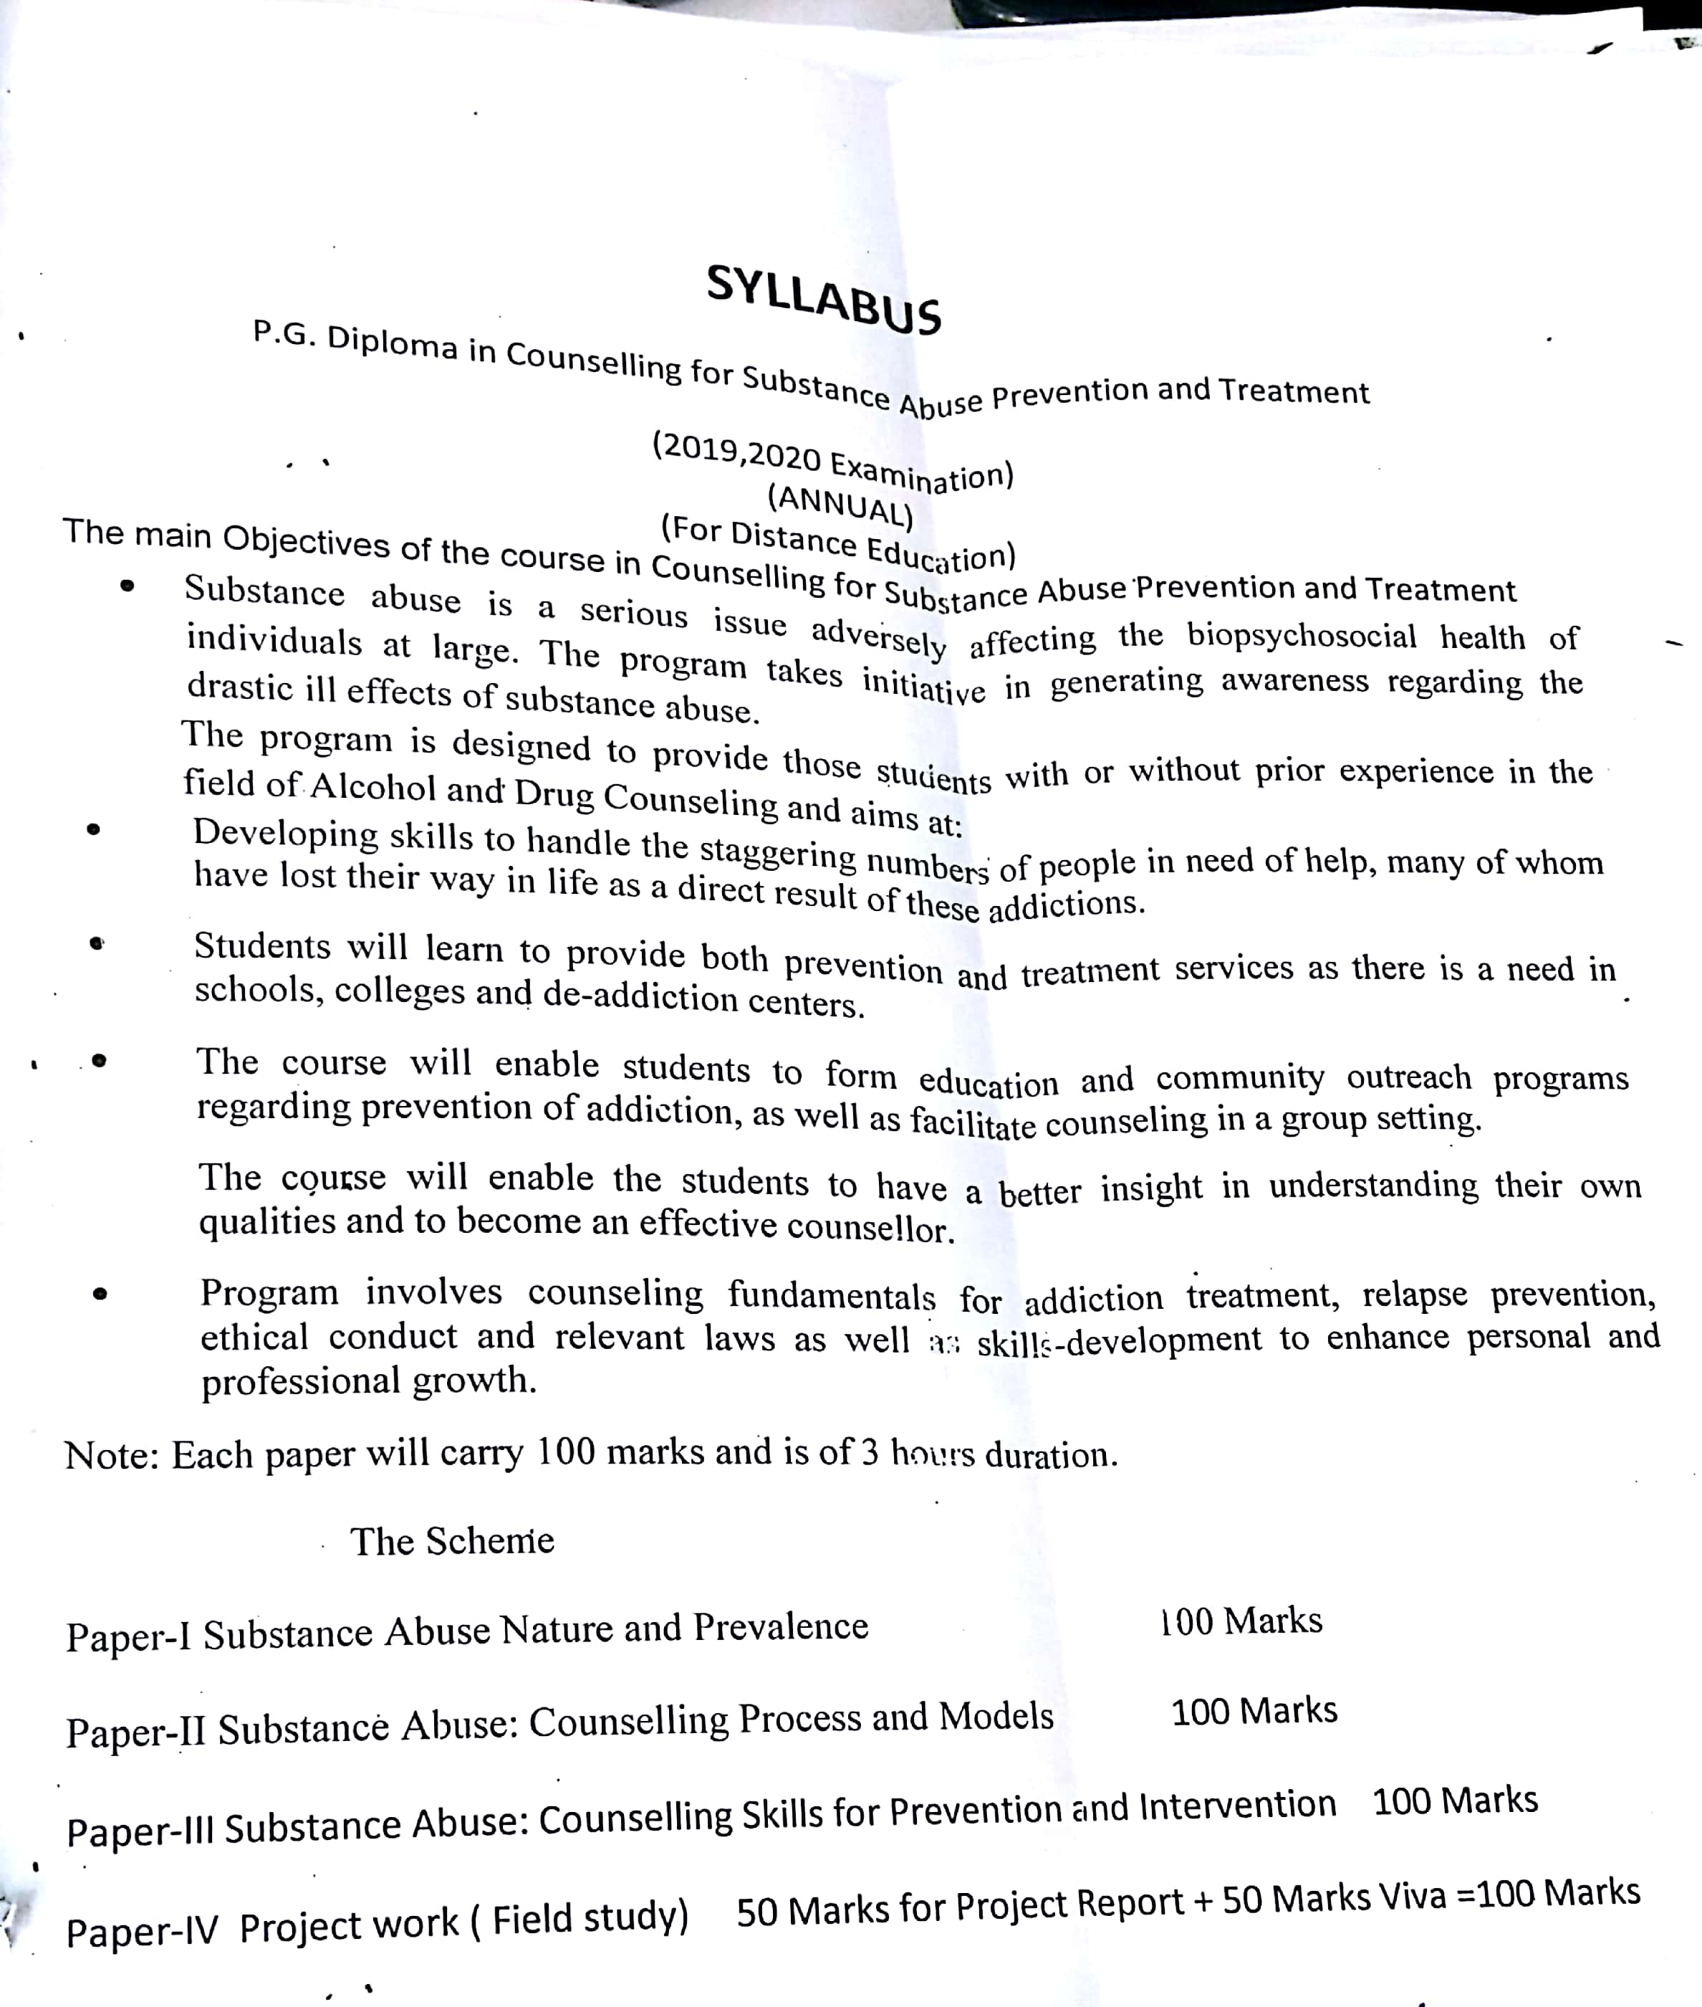

Syllabus
POST GRADUATE DIPLOMA IN COUNSELLING FOR SUBSTANCE ABUSE PREVENTION AND TREATMENT
Paper -I SUBSTANCE ABUSE : NATURE AND PREVALENCE
Max Marks: 100 Max Time: 3 hrs

INSTRUCTIONS FOR THE PAPER SETTERS
The question paper will consist of three sections A, B and C. Each of sections A and B will have four questions from the respective sections of the syllabus. Each question shall carry 15 marks. Section C will consist of 10 short answer type of 4 marks each.
INSTRUCTIONS FOR THE CANDIDATES
Candidates are required to attempt any two questions from section A and any two questions from section B. Section C is compulsory.
SECTION A
UNIT: I - (a) Substance Abuse: Nature, Abuse, Dependence and Addiction
(b) Epidemiology of substance Abuse: Prevalence and Extent
Vulnerable societies and individuals with special reference to India and Punjab.
UNIT: II (a) Substance Abuse : Assessment and diagnosis (DSM V)
(b) Signs and Symptoms of Substance Abuse: Physical, Academic, Behavioral and Psychological indicators

SECTION B
UNIT: III (a) Biological Causes of Substance Abuse
(b) Psychosocial and Cultural Causes
UNIT: IV (a) Types of substance abuse: Stimulants, Depressants, Narcotics, Hallucinogens, Steroids and Inhalants
(b) Consequences- For individuals, families, and Community with special reference to India and Punjab.

Suggested Readings
- Kapoor.T. (1985.) Drug Epidemic among Indian Youth, New Delhi: Mittal Pub
- Modi, Ishwar and Modi, Shalini (1997.) Drugs: Addiction and Prevention, Jaipur: Rawat Publication.
- Ahuja, Ram,(2003.),Social Problems in India, Rawat Publications: Jaipur
- David M. McDowell and Henry I. Spitz. (2016). Substance Abuse: From Principles to practice. Routledge.
- Cecilia A. Essau. (2014). Substance Abuse and Dependence in Adolescence: Epidemology, risk factors and treatment. Routledge.
- 2003 National Household Survey of Alcohol and Drug Abuse. New Delhi, Clinical Epidemiological Unit, All India Institute of Medical Sciences, 2004.
- World Drug Report (2011.), United Nations Office of Drug and Crime.
- Andrew L. Cherry, Mary E. Dillon, Douglas Rugh. (2002). Substance Abuse: A Global View. USA. Greenwood Publishing group.

POST GRADUATE DIPLOMA IN COUNSELLING FOR SUBSTANCE ABUSE PREVENTION AND TREATMENT
Paper -II SUBSTANCE ABUSE: COUNSELLING PROCESS AND MODELS
Max Marks: 100 Max Time: 3hrs
Total Marks 100
INSTRUCTIONS FOR THE PAPER SETTERS
The question paper will consist of three sections A, B and C. Each of sections A and B will have four questions from the respective sections of the syllabus. Each question shall carry 15 marks. Section C will consist of 10 short answer type of 4 marks each.
INSTRUCTIONS FOR THE CANDIDATES
Candidates are required to attempt any two questions from section A and any two questions from section B. Section C is compulsory.
SECTION A
UNIT: I – Nature of Counselling and Ethical Issues
- Introduction to Counselling: Nature, Scope, Types of counseling. Characteristics of effective counselor.
- Ethical Issues in Counselling

UNIT:II
- Counselling Process: Stages of Counselling, Substance abuse: Interview, Screening and Assessment.
- Understanding substance abuse from different perspectives of counseling: Individual,
Family-centered and Group counseling
SECTION B
UNIT: I1I Prevention of Substance Abuse
(a) Models of Prevention: Social cognitive, Social developmental, Social context and Peer resource programming model
(b) Learning models: Information, Responsible–use, and Affective education model.
UNIT: IV
(a) Intervention Programs: Self-help groups (Alcoholic Anonymus, Narcotic Anonymus; Role of Family; Gender -Specific Intervention
(b) Maintaining Change in Substance abuse behavior
Concept of Relapse: Process and Prevention strategies (Social support, Lifestyle change, and Cognitive behavioural approach.
Suggested Readings
- Scott T. Walters and Frederick Rotgers. (2012). Treating Substance Abuse: Theory and Technique. London. The Guilford publications.
- Patricia Stevens and Robert L. Smith. (2017). Substance use counseling: Theory and Practice. New York. Pearson publications.
- Judith A. Lewis, Robert Q. Dana and Gregory A. Blevins. (2015). Substance Abuse Counseling. USA. Cengage learning.
- Shulamith Lala Ashenberg Straussner. (2014). Clinical work with Substance-Abusing Clients. New York. Guilford Publications.
- World Drug Report 2011, United Nations Office of Drug and Crime.
- Andrew L. Cherry, Mary E. Dillon, Douglas Rugh. (2002). Substance Abuse: A Global View. USA. Greenwood Publishing group.
- Mary Marden velasquez, Cathy Crouch, Nanette Stokes Stephens and Carlo C. Diclemente. (2016). Group Treatment for Substance Abuse: A Stages-of-Change therapy Manual (2nd Edition). New York. Guilford publications Inc.
POST GRADUATE DIPLOMA IN COUNSELLING FOR SUBSTANCE ABUSE PREVENTION AND TREATMENT
Paper-III SUBSTANCE ABUSE: COUNSELLING SKILLS FOR PREVENTION AND INTERVENTION
Max Marks: 100 Max Time: 3 hrs.
Total Marks 100
INSTRUCTIONS FOR THE PAPER SETTERS
The question paper will consist of three sections A, B and C. Each of sections A and B will have four questions from the respective sections of the syllabus. Each question shall carry 15 marks. Section C will consist of 10 short answer type of 4 marks each.
INSTRUCTIONS FOR THE CANDIDATES
Candidates are required to attempt any two questions from section A and any two questions from section B. Section C is compulsory
SECTION A
UNIT: I – Role of Counselor and Counselling Skills
( a) Counselling Skills
(b) Role of Counselor, Parents and Teachers (school environment, teacher training, student assistance programs) in psychotherapeutic process
Issues in Prevention: Attitudes and Challenges to the prevention of substance abuse;.
UNIT:II-
- Intervention Approaches: Cognitive, Behavioral and Affective.
- Motivational Interviewing: FRAMES, DARES and Stages of Change; Behavioral self-control and mindfulness training.
SECTION B
UNIT: III –
- Icelander Model of Substance abuse; Buddy program (Punjab)
- Minnesota model (12 step facilitation) Motivational enhancement approach (MEA). Cue Exposure Treatment (CET), Community Reinforcement Approach (CRA).
UNIT: IV- Legal issues in India:
- Brief Introduction to legal issues related to substance possession and abuse.
- Substance abuse prevention practice code of ethics.
Suggested readings
1. Scott T. Walters and Frederick Rotgers. (2012). Treating Substance Abuse: Theory and Technique. London. The Guilford publications.
2. Patricia Stevens and Robert L. Smith. (2017). Substance use counseling: Theory and Practice. New York. Pearson publications.
3. Judith A. Lewis, Robert Q. Dana and Gregory A. Blevins. (2015). Substance Abuse Counseling. USA. Cengage learning.
4 .Shulamith Lala Ashenberg Straussner. (2014). Clinical work with Substance-Abusing Clients. New York. Guilford Publications.
- World Drug Report 2011, United Nations Office of Drug and Crime.
- Andrew L. Cherry, Mary E. Dillon, Douglas Rugh. (2002). Substance Abuse: A Global View. USA. Greenwood Publishing group.
- Mary Marden velasquez, Cathy Crouch, Nanette Stokes Stephens and Carlo C. Diclemente. (2016). Group Treatment for Substance Abuse: A Stages-of-Change therapy Manual (2nd Edition). New York. Guilford publications Inc.

Paper 4: Project Report
(ANNUAL)
(For Distance Education )
- Project report /case study will be of 100 marks (50 for Project Report and 50 for viva). Total marks will be 100.
- The Project Report may be submitted without any late fee on or before 31st May of every session. Candidates failing to submit the project report within stipulated time will be charged with late fee of Rs 500/ per month after 31 May till August that too with the permission of Dean, Academic Affairs on recommendation of subject in-charge and head of the department of distance education upto three months.
Beyond three months, as special case, with the permission of Vice Chancellor and with the fee of Rs 5000/- in addition to Rs. 500 per month till November . No further extension will be allowed beyond month of November.
- Fee charged for project report submission will be utilized for the evaluation of project report, conducting viva and other related expenses.
- Rs. 100 /- per project will be paid as evaluation fee to the evaluator of project reports and Rs 50/- will be paid to internal examiner.
- Viva –Voce of candidate submitting project report after the stipulated time i.e 31 may will be conducted in next session.

